DAA – LAB EXPERIMENTS
Ch. Bhargav Ram
Reg. No.: 192425334
Date: 01-10-2026
Experiment 1
CODE:
def first_pal(words):
for w in words:
if w == w[::-1]:
return w
return ""
items = ["abc", "car", "ada", "racecar", "cool"]
print(first_pal(items))
OUTPUT:
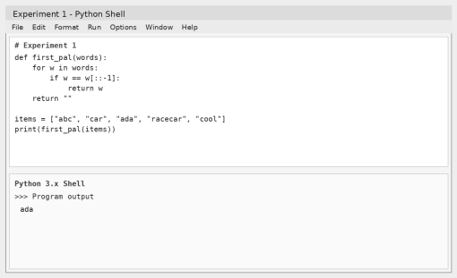
Experiment 2
CODE:
def common_counts(a, b):
c1 = 0
c2 = 0
for value in a:
if value in b:
c1 += 1
for value in b:
if value in a:
c2 += 1
return [c1, c2]
a = [2, 3, 2]
b = [1, 2]
print(common_counts(a, b))
OUTPUT:
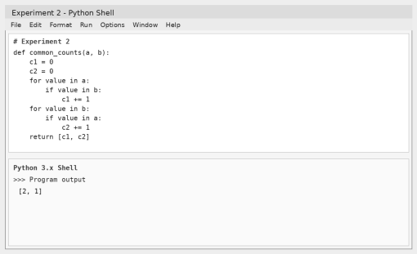
Experiment 3
CODE:
def total_unique(nums):
total = 0
size = len(nums)
for start in range(size):
seen = set()
for end in range(start, size):
seen.add(nums[end])
total += len(seen) ** 2
return total
data = [1, 2, 1]
print(total_unique(data))
OUTPUT:
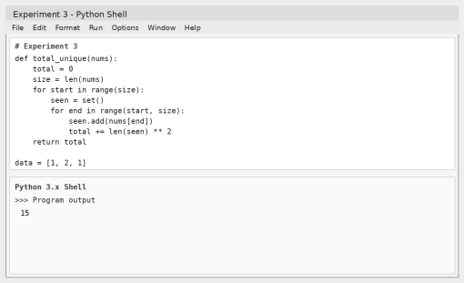
Experiment 4
CODE:
def valid_pairs(values, k):
pairs = 0
n = len(values)
for first in range(n):
for second in range(first + 1, n):
if values[first] == values[second] and (first * second) % k == 0: pairs += 1
return pairs
values = [3, 1, 2, 2, 2, 1, 3]
k = 2
print(valid_pairs(values, k))
OUTPUT:
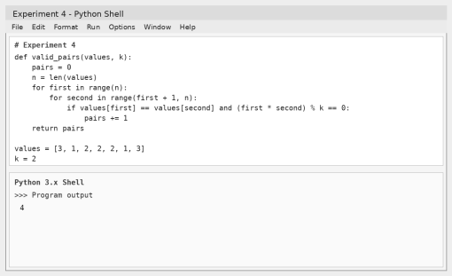
Experiment 5
CODE:
def largest_value(data):
biggest = data[0]
for value in data:
if value > biggest:
biggest = value
return biggest
print(largest_value([1, 2, 3, 4, 5]))
print(largest_value([7, 7, 7, 7, 7]))
print(largest_value([-10, 2, 3, -4, 5]))
OUTPUT:
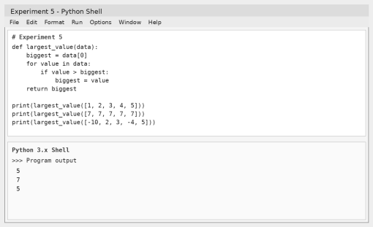
Experiment 6
CODE:
def maximum_after_sort(data):
if not data:
return None
data.sort()
return data[-1]
print(maximum_after_sort([]))
print(maximum_after_sort([5]))
print(maximum_after_sort([3, 3, 3, 3, 3]))
OUTPUT:
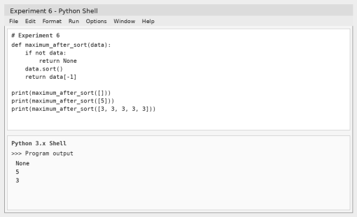
Experiment 7
CODE:
def unique_values(data):
return list(set(data))
print(unique_values([3, 7, 3, 5, 2, 5, 9, 2]))
print(unique_values([-1, 2, -1, 3, 2, -2]))
print(unique_values([1000000, 999999, 1000000]))
OUTPUT:
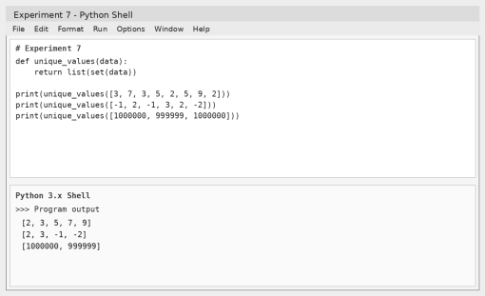
Experiment 8
CODE:
def bubble_sort(values):
n = len(values)
for pass_no in range(n - 1):
for j in range(n - pass_no - 1):
if values[j] > values[j + 1]:
values[j], values[j + 1] = values[j + 1], values[j]
return values
numbers = [5, 3, 8, 1, 2]
print(bubble_sort(numbers))
OUTPUT:
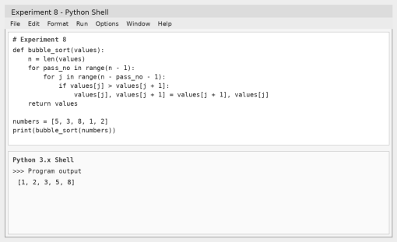
Experiment 9
CODE:
def binary_search(values, target):
values.sort()
low = 0
high = len(values) - 1
while low <= high:
middle = (low + high) // 2
if values[middle] == target:
return middle + 1
elif values[middle] < target:
low = middle + 1
else:
high = middle - 1
return -1
numbers = [3, 4, 6, -9, 10, 8, 9, 30]
target = 10
position = binary_search(numbers, target)
if position != -1:
print("Element", target, "is found at position", position)
else:
print("Element", target, "is not found")
OUTPUT:
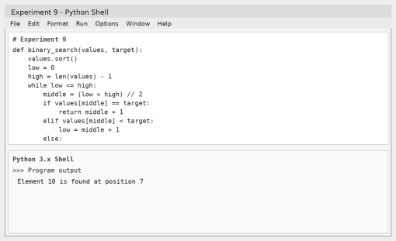
Experiment 10
CODE:
def merge_sort(values):
if len(values) <= 1:
return values
middle = len(values) // 2
left = merge_sort(values[:middle])
right = merge_sort(values[middle:])
merged = []
i = j = 0
while i < len(left) and j < len(right):
if left[i] <= right[j]:
merged.append(left[i])
i += 1
else:
merged.append(right[j])
j += 1
merged.extend(left[i:])
merged.extend(right[j:])
return merged
numbers = [5, 2, 3, 1, 4]
print(merge_sort(numbers))
OUTPUT:
